Central Shops historic district plans and Design Standards

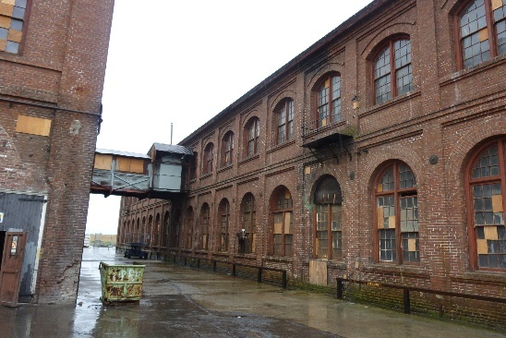
Project Description
As part of the Environmental Impact Report for the Railyards Specific Plan, the developer of the Railyards, Downtown Railyard Ventures (DRV), is required to prepare the Historic District Plan (HDP) for the designated City Historic District, the Central Shops. Architectural Resources Group (ARG) have been retained by DRV to prepare the HDP for the Central Shops.

The Central Shops Historic District Plans and Design Guidelines
The Historic District Plans will be comprised of one comprehensive document with individual chapters for each of the Historic Districts. Historic District Plans will include:

- Introduction
- Physical Description & Boundaries
- Brief Historic Context
- Significance
- Character-Defining Features
- District Map
- District-Specific Standards & Criteria
- Appendices

How the Historic District Plans and Design Guidelines will Benefit the City
Development and implementation of the Central Shops Historic District Plan will bring greater clarity for staff and project proponents about what kind of development is compatible within each historic district. The current city process relies on a broad set of criteria known as The U.S. Secretary of the Interior Standards for the Treatment of Historic Properties. Those guidelines do not provide specifics on site planning, or on compatible infill design within historic settings, nor do they provide design guidance or standards unique to the Central Shops Historic District.

Public Outreach
Feedback will be considered on an on-going basis during the draft document stage. A series of public meetings and hearings will be held to allow public input throughout the planning process. Individual meetings will be scheduled with groups on an as-needed basis to allow for one-on-one dialogue with city staff.

Project Contact
Sean de Courcy, Associate Preservation Planner, Community Development Department
sdecourcy@cityofsacramento.org

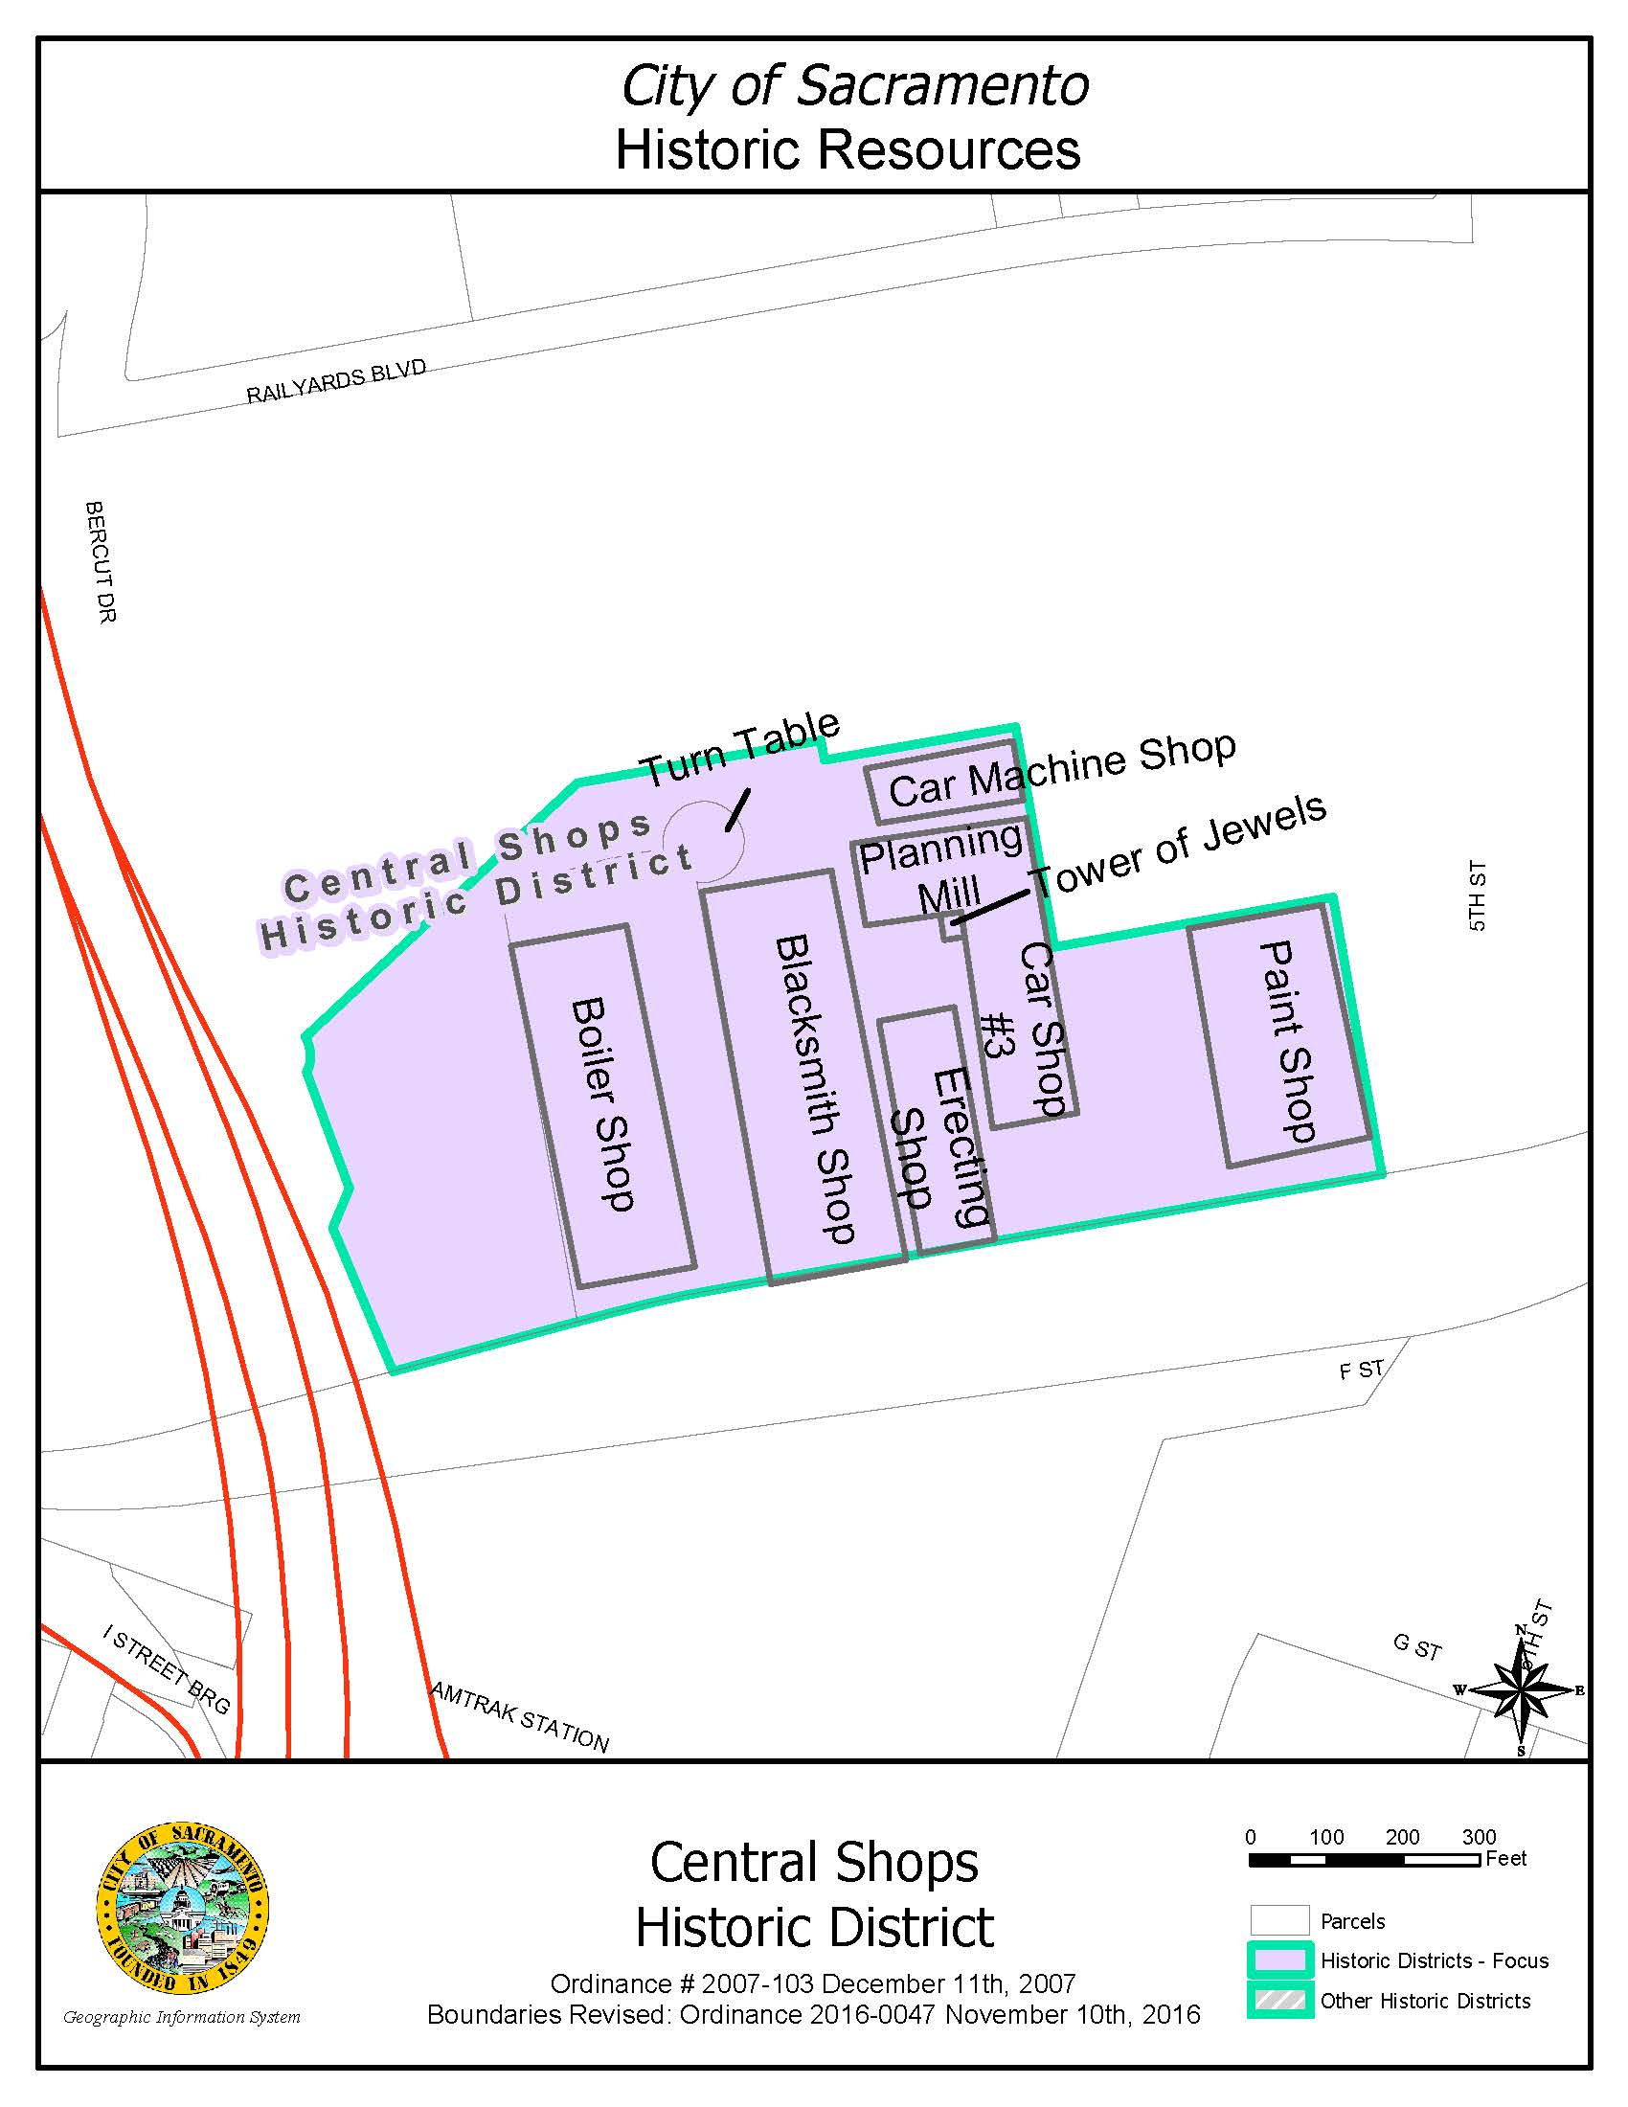

Contributing Resources

The Car Machine Shop
The Planning Mill
Privy
Car Shop No. 3
Blacksmith Shop
Paint Shop
Erecting Shop
Boiler Shop
Site Features

Turntable

