How to Measure the Diameter of a Tree

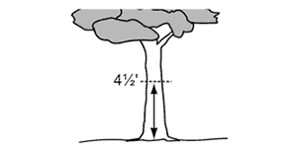

Diameter at standard height (DSH), is a common method used for measuring trees. DSH refers to a tree’s diameter measured at 4.5 feet (54 inches) above the ground. Using a string, a measuring tape, a thumb tack, and a calculator, the diameter of a tree can easily be calculated by completing the following steps:

- With the measuring tape, measure 4.5 feet up the trunk of the tree from the ground. Use a thumb tack to mark the height on the tree.
- Wrap your string around the tree trunk at 4.5 feet. Make sure the string is straight and tight around the trunk, and mark or cut the circumference on the string.
- Measure the length of string to get the circumference of the tree.
- Convert the circumference measurement to diameter by dividing the circumference by pi (3.14). The total is the tree’s DSH.

