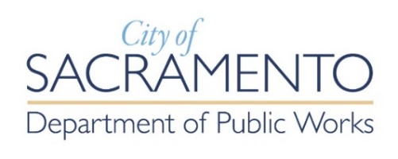
Non-Exclusive Commercial
Solid Waste Collection Franchise
Application Checklist

Franchise Application Checklist
(Non-Exclusive Commercial Solid Waste Commercial Franchise Application)
Send completed application and all attachments to: wastecompliance@cityofsacramento.org

☐ Completed Non-Exclusive Commercial Solid Waste Collection Franchise Application
- Sections 1-7 and 9 for returning franchise applicants.
- Section 1-9 for new applicants.
Attachments to Application:
☐ Vehicle Inventory – List of all Vehicles (Section 4.B)
☐ Diversion Plan (must include all topics as outlined in the Diversion Plan Template for Franchisees)
☐ New Applicants Only - Financial Review Document (Section 8)
☐ (If applicable) If more than 1 qualifying individual answers yes to Section 7.1 or 7.2 of the Non-Exclusive Franchise Agreement, a separate sheet for each additional qualifying individual must be attached

Within 10 days of Receiving Intent to Award a Franchise Received from City Council:
☐ All insurance certificates evidencing coverage as required in the Franchise Agreement (Section 5.C)

